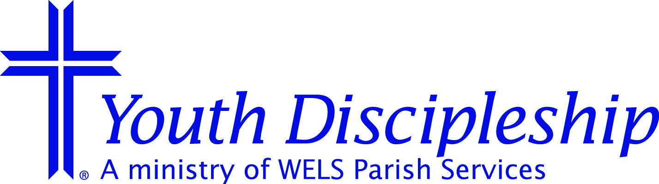
District Commission on Youth Discipleship Report
CA Pastors’ Conference
January 26-27, 2009

Publicity
Websites
- AZ/CA District Youth Discipleship www.welscyd.net/arizonacalifornia
- WELS CYD: www.wels.net/youthdiscipleship
- Early Childhood: www.wels.net then jumpword “ecm”
- Kids’ Connection: www.kidsconnection.tv
- Living Bold for teens: www.livingbold.net and www.myspace.com/livingbold
- WELS Int’l Youth Rally: www.welsyouthrally.net
- Parents Crosslink: www.parentscrosslink.net
- WELS.net University: www.wels.net then jumpword “university” – This site currently has 20 mini courses for Sunday School and 4 for Parenting.

Newsletters
To save $33,000 these three newsletters are no longer being printed and mailed. Subscriptions have gone from about 10,000 down to 520 for the three. Go to www.wels.net/youthdiscipleship and click on “Newsletters” to read and print the newsletters yourself. You can also subscribe to the “Newsletter Email Service” to be notified when new issues are uploaded.
- Sowers & Seeds – for Early Childhood ministry
- Partners – for Sunday School ministry
- REACH! – for Teen ministry

International Youth Rally
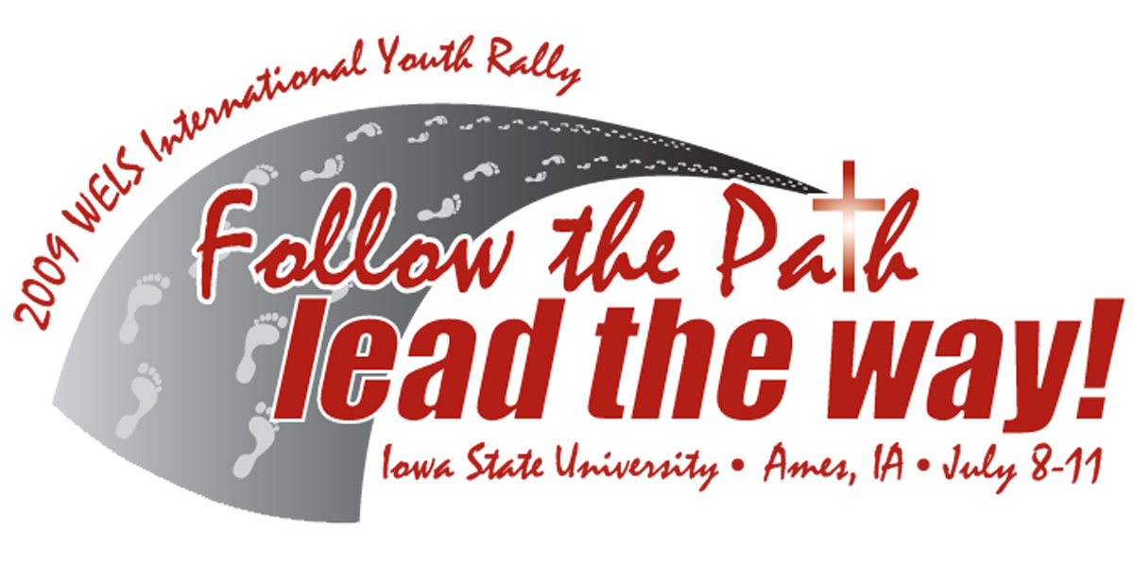
Before the holidays, the 28 page information booklet, sharing all the details about the 2009 WELS International Youth Rally (July 8-11), was mailed out to all WELS and ELS congregations. If you did not get one or would like to see one, contact the CYD office or go to www.welsyouthrally.net.
- Online registration window: March 2-April 3 for Contact Youth Leaders
- Two cash prize contests: “Rally Commercial” and “WELS Got Talent”. Deadline for submissions: March 15.

Camps
- White Mountain Christian Camp will be held at Camp Grace in Lakeside, AZ, June 14-19, 2009. (Contact: Staff Minister Mike Mundstock.)
- Tree of Life Bible Camp at Capitol Mountain (Colfax, CA) willl be held July 12-18, 2009. http://treeoflifebiblecamp.org/
- Good Shepherd Bible Camp is planned for July 19-25, 2009, at Camp Morning Star (Angeles Oaks, CA). (Contact: Pastor David Warskow.) http://lutherangsbc.blogspot.com/

Confirmation Self-Study Nearing Completion
Final editing is being done on the video and print components. When completed the resource will include the self-study instrument, a DVD video with interviews and descriptions of “best practice” around WELS, a clearinghouse of helpful “home grown” resources, and a Seminary reviewed discussion paper titled, “Can Children Properly Receive the Lord’s Supper in WELS?” Late winter/early spring 2009 is targeted for the release. Estimated selling price: $14.95.
Y-ME Academies
CYD is following the lead of the highly successful regional “schools” used by the Commissions on Evangelism and Worship. CYD’s effort will be called, “Youth Ministry Enhancement (Y-ME) Academy.” Development of the Y-ME Academy process and resources is being funded by a Thrivent Church-wide Grant. Program development is in the final stages. If your congregation would be interested in being part of the field test, contact me.

CYD Resources Catalog
Web and PDF versions of the CYD Resource Catalog are available on the CYD Web site (www.wels.net/youthdiscipleship).

“Everyday” Video Project for LivingBold
About half of the 50 devotional videos for streaming on LivingBold.net and Streams.WELS.net have been produced and posted. So far, the reactions to these high quality videos using WELS youth as the actors, have been very favorable. The videos cover real-life issues youth face under the themes: Everyday Sins, Faith, Relationships, Hope, and Victories. If CYD can obtain a 2009 grant from the Thrivent funds given to WELS each year, all of the videos with companion Bible studies will be released in a stand-alone resource.

Christ-Light 2 Development On-going

Northwestern Publishing House (NPH) is aggressively pursuing the revision of WELS religion curriculum, Christ-Light. Titled Christ-Light 2, the revision will include many content and format improvements as well as state-of-the-art helps for teachers. In the revision, Sunday schools will have their own curriculum, minimizing some of the coordination issues encountered in congregations with a Sunday School and a Lutheran elementary school. Because of the magnitude of this project and the hundreds and hundreds of production steps required, NPH does not anticipate the revised curriculum will hit shelves for at least 3 more years.

Ongoing
Working to make the AZ/CA District CYD (www.welscyd.net/arizonacalifornia) site informative and useful. If you have information to share about any aspect of youth ministry (all ages) please email it to me. I have started an electronic lending library (under “Youth Ministry Files”) on the website with some Christmas for Kids files. If you or someone you know has good stuff to share, let me know and I will ask them to share.

How can we help?
I am attending a CYD meeting with all the coordinators and administrators in February. Please give me your input on any youth ministry topics or resources. What resources would you like? Let me know how CYD can help you so I can give them feedback from our district. In addition the commission members below are available at the district level for ideas and resources.

May the Lord bless all of us in this ministry to our and his children!

In Christ’s service,

Pastor Matt Pfeifer, Coordinator
1799 Wigwam Parkway
Henderson, NV 89074
Home: (702) 614-9058

Office: (702) 454-8979
Fax: (702) 454-0528
pastormatt@gvelc.com

Staff Minister Michael Mundstock
2114 W McRae Way
Phoenix, AZ 85027-5129
623-581-1198
desertdeacon@cox.net
Pastor Gary Pufahl
5244 Tujunga Ave
North Hollywood, CA 91601-3120
818-761-1846
stpaulsnhrevp@hotmail.com

Pastor Nathan Kassulke
830 N 1st Ave
Tucson, AZ 85719-4812
520-623-6633
revnpk@gracetucsonwels.com

